4.2 & 4.3 Double Integrals Worksheet

- Integrate over the domain D, where D is the region bounded by .
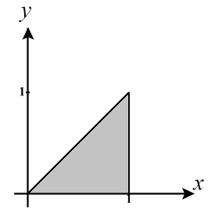
We sketch a picture of the region D and define D as:

Therefore, we compute:

- Find the volume of the solid that is bounded above by the cylindrical surface and below by the domain enclosed by the parabola and the line .
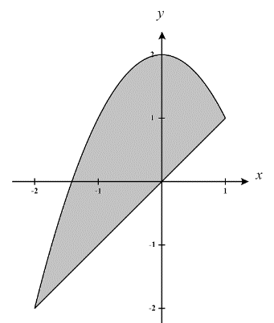
We sketch a picture of the region of integration and define D as:

Therefore, we compute:

- Use a double integral to determine the area of the region given by which exists above the x-axis.
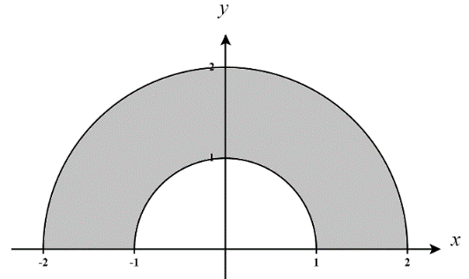
We sketch a picture of the region of integration and define D in polar coordinates:

Therefore, we compute:

- A cylindrical drill bit is used to bore a vertical hole through the center of the solid bounded above by the graph of and bounded below by the region in the xy-plane given by . What is the radius of the drill bit if 10% of the volume of the solid is removed?
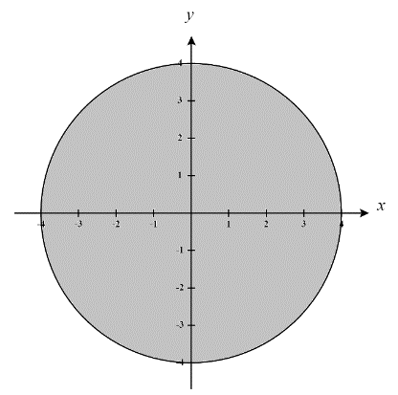
If we can determine the volume of the entire solid then we can easily determine the remaining volume after 10% has been removed. To find the volume of the entire solid we begin by sketching a picture of the region of integration and D in polar coordinates.

We define D in polar coordinates:
Therefore, the volume of the entire solid is given by:

We proceed by doing a u-sub. Let then .
Our bounds become . So we get,

Therefore the volume of the drilled out portion needs to be .
The cylinder that was drilled out was located at the origin and at this point the surface has a height of and therefore our cylinder here has a height of 25. This means that the volume equation for this cylinder can be written as . This implies that
- The integral has the form when converted into polar coordinates.
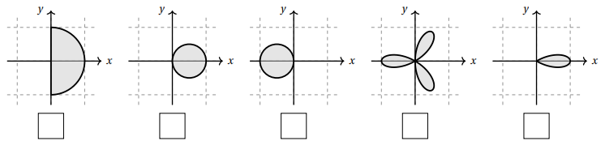
  - Mark the box below with the picture of the region that represents R.

  - Fill in the missing integrand to convert this integral into polar coordinates.

- Determine the volume of the region that lies under the sphere , above the plane and inside the cylinder .
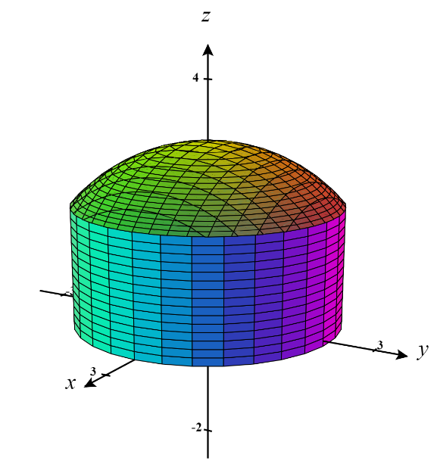
We begin by sketching a picture of the solid in question here.

To find the volume of the entire solid we see that we are working under the sphere and above the disk bounded by in the xy-plane. Since we are integrating over the disk we will approach this question using polar coordinates. Let D represent the disk bounded by and note that

We define D in polar coordinates:

Therefore, the volume of the entire solid is given by:
We proceed by doing a u-sub. Let then .
Our bounds become . So we get,
- Use a double integral to determine the area of the region bounded by the curves and on the interval from .
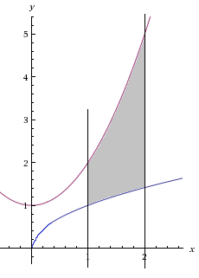
$$\left(1, 1\right)$$
$$\left(1,2\right)$$
$$\left(2, \sqrt{2}\right)$$
$$\left(2, 5\right)$$
We sketch a picture of the region of integration D and define D as:
(Note how difficult it would be to define this region if we wanted to setup differentials in the order dxdy.)

Therefore, we compute:

- Evaluate the integral .

Trying to tackle this question in cartesian coordinates will be difficult, therefore we will attempt to convert to polar coordinates. We see that the region of integration D can be defined as:
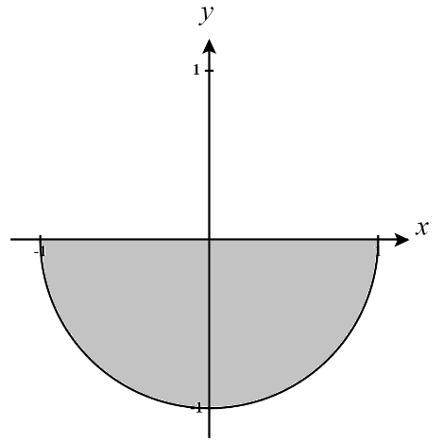
We recognize the lower bound on y as the bottom half of a circle of radius 1 centered at the origin and therefore the region D looks like the region shown at the right.

We then redefined D using polar coordinates:

Now, we compute the integral as follows:

